Mobile Store Management

Aim:

To create a mobile store management application using WinForm .Application involves following:

* Billing
* Adding / Modifying Stock details
* View status of Stock remaining
* View All transaction done

Abstract:

We are creating a mobile store management application (Windows application). We use C#.NET framework top accomplish the project using Visual Studio IDE. The Project concentrates on three modules –

Create Bill by adding items into user’s purchase list and develop bill for the same indicating the total amount to be paid. Here the quantity for the purchased item will also be reduced accordingly

Adding stocks into master DB of the mobile store .This can be done in two ways i) We can add a new item (Mobile) along with its product code, quantity and price. Ii) We can modify the quantity for the existing item which will be updated in DB.

Billing history is provided so admin can view all the transactions done so far.

Stock Details can also be reviewed using another Window. This will display all the stock at first. Also stock listing can be done categorically

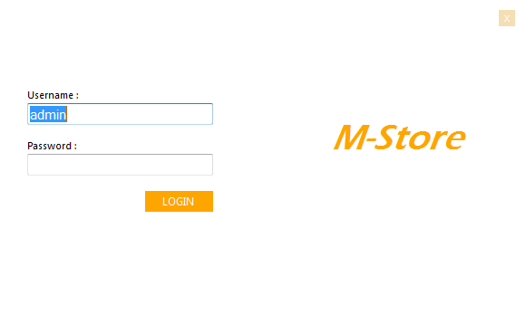LOGIN PAGE

MENU PAGE

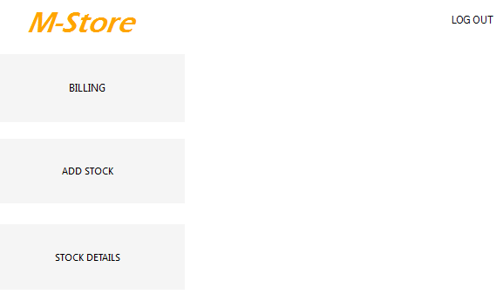

BILLING PAGE

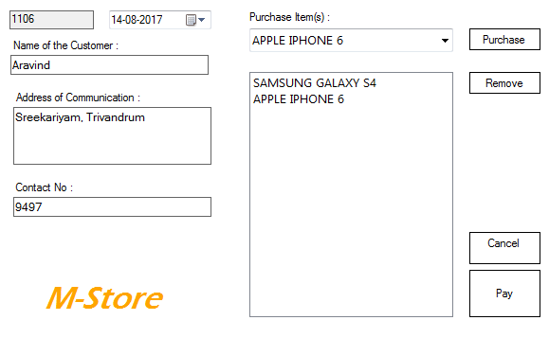

PAY BILL WINDOW

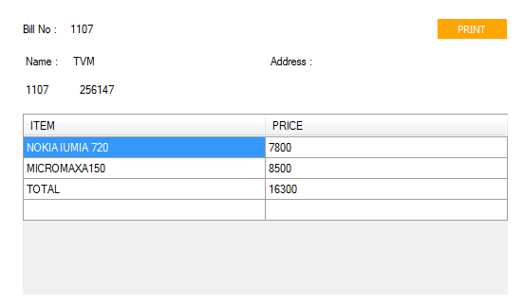

MODIFY STOCK WINDOW

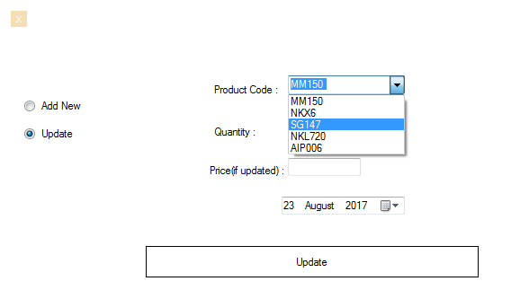

ADD STOCK WINDOW

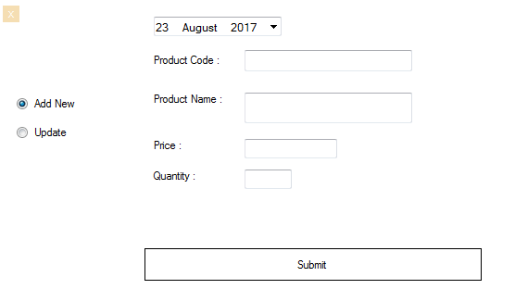

VIEW STOCK WINDOW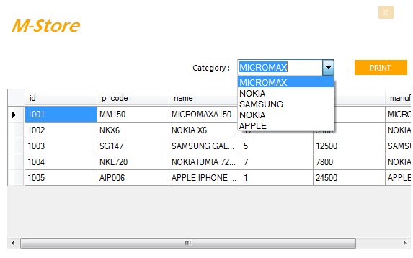

VIEW STOCK WINDOW (CATEGORY) 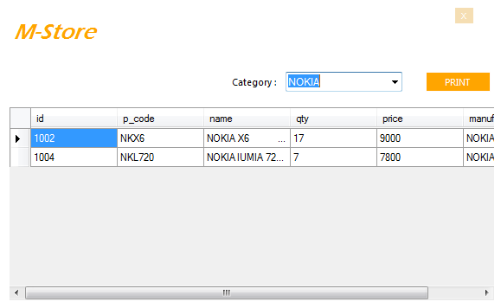

VIEW PURCHASES (BILLS)

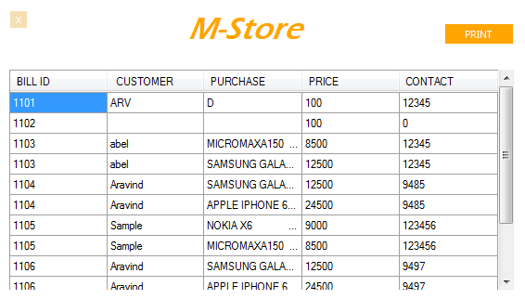

Code

/*billing.cs*/

using System.Data.SqlClient;

namespace MobileStore

{

public partial class billing : Form

{

SqlConnection con = new SqlConnection("Data Source=NETWORKZ-PC;Initial Catalog=MobileStore;Integrated Security=True");

public billing()

{

InitializeComponent();

con.Open();

string billid = "SELECT (MAX(bill_id)+1) FROM billing";

SqlCommand cmd = new SqlCommand(billid, con);

SqlDataReader dr = cmd.ExecuteReader();

dr.Read();

bill_no.Text = (dr[0]).ToString();

con.Close();

}

private void button1_Click(object sender, EventArgs e)

{

ItemsBox1.Items.Add(comboBox1.Text);

}

private void button2_Click(object sender, EventArgs e)

{

ItemsBox1.Items.Remove(ItemsBox1.SelectedItem);

}

private void button4_Click(object sender, EventArgs e)

{

Menu m = new Menu();

this.Hide();

m.Show();

}

private void button3_Click(object sender, EventArgs e)

{

con.Open();

foreach (object ob in ItemsBox1.Items)

{

string item = ob.ToString();

string update1 = "UPDATE stock SET qty= (SELECT qty-1 FROM stock WHERE name='"+item+"') WHERE name='"+ob.ToString()+"'";

SqlCommand cmd1 = new SqlCommand(update1, con);

cmd1.ExecuteNonQuery();

string priceqry = "SELECT price FROM stock WHERE name='"+item+"'";

SqlCommand cmdprice = new SqlCommand(priceqry, con);

SqlDataReader dr = cmdprice.ExecuteReader();

dr.Read();

string price = (dr[0]).ToString();

dr.Close();

string update = "INSERT INTO billing(bill_id,cust_name,address,contact,items,total) VALUES("+bill_no.Text+",'" + cust_name.Text + "','" + address.Text + "'," + contact.Text + ",'" + item + "',"+price+")";

SqlCommand cmd = new SqlCommand(update, con);

cmd.ExecuteNonQuery();

}

Pay p = new Pay();

p.Show();

this.Hide();

con.Close();

}

}

}

/*Pay.cs*/

using System.Data.SqlClient;

namespace MobileStore

{

public partial class Pay : Form

{

public Pay()

{

int total = 0;

InitializeComponent();

SqlConnection con = new SqlConnection("Data Source=NETWORKZ-PC;Initial Catalog=MobileStore;Integrated Security=True");

con.Open();

string billid = "SELECT bill_id,cust_name,address,contact,items,total FROM billing WHERE bill_id=(SELECT MAX(bill_id) FROM billing)";

SqlCommand cmd = new SqlCommand(billid, con);

SqlDataReader dr = cmd.ExecuteReader();

while (dr.Read())

{

billNo.Text = (dr[0]).ToString();

labelname.Text = (dr[2]).ToString();

label3.Text = (dr[3]).ToString();

contact.Text = (dr[0]).ToString();

string items = dr[4].ToString();

string price = dr[5].ToString();

total = total + Convert.ToInt16(price);

var index = dataGridView1.Rows.Add();

dataGridView1.Rows[index].Cells["item"].Value = items;

dataGridView1.Rows[index].Cells["price"].Value = price.ToString();

}

this.dataGridView1.Rows.Add("TOTAL ", total);

con.Close();

}

} } }

/*Add_stock.cs*/

namespace MobileStore

{

public partial class add_stock : Form

{

SqlConnection con = new SqlConnection("Data Source=NETWORKZ-PC;Initial Catalog=MobileStore;Integrated Security=True");

public add_stock()

{

InitializeComponent();

panel2.Hide();

}

private void add_stock_Load(object sender, EventArgs e)

{

// TODO: This line of code loads data into the 'mobileStoreDataSet1.stock' table. You can move, or remove it, as needed.

this.stockTableAdapter.Fill(this.mobileStoreDataSet1.stock);

panel1.Show();

}

private void button1_Click(object sender, EventArgs e)

{

SqlConnection con = new SqlConnection("Data Source=NETWORKZ-PC;Initial Catalog=MobileStore;Integrated Security=True");

con.Open();

string update="INSERT INTO stock(p_code,name,qty,price) VALUES('"+pcode.Text+"','"+pname.Text+"',"+Convert.ToInt16(qty.Text)+","+Convert.ToInt16(price.Text)+")";

SqlCommand cmd = new SqlCommand(update, con);

int returnvalue=cmd.ExecuteNonQuery();

if (returnvalue!=0)

MessageBox.Show("Added Successfully");

con.Close();

}

private void radioButton2_CheckedChanged(object sender, EventArgs e)

{

panel1.Hide();

panel2.Show();

}

private void radioButton1_CheckedChanged(object sender, EventArgs e)

{

panel2.Hide();

panel1.Show();

}

private void button2_Click(object sender, EventArgs e)

{

con.Open();

string update = "UPDATE stock SET qty=" + qtynew.Text + ",price=" + pricenew.Text + " WHERE p_code='" + pcode_update.Text + "'";

SqlCommand cmd = new SqlCommand(update, con);

int returnvalue = cmd.ExecuteNonQuery();

if (returnvalue != 0)

MessageBox.Show("Added Successfully");

con.Close();

}

private void pcode_update_SelectedIndexChanged(object sender, EventArgs e)

{

con.Open();

string update_var = "SELECT qty,price FROM stock WHERE p_code='" + pcode_update.Text + "'";

SqlCommand cmd = new SqlCommand(update_var, con);

SqlDataReader dr = cmd.ExecuteReader();

dr.Read();

int qty = Convert.ToInt16((dr[0]));

int price = Convert.ToInt16((dr[1]));

pricenew.Text=price.ToString();

qtynew.Text = qty.ToString();

con.Close();

}

private void button1_MouseEnter(object sender, EventArgs e)

{

button1.BackColor = Color.Orange;

}

private void button1_MouseLeave(object sender, EventArgs e)

{

button1.BackColor = Color.WhiteSmoke;

}

private void button2_MouseLeave(object sender, EventArgs e)

{

button2.BackColor = Color.WhiteSmoke;

}

private void button2_MouseEnter(object sender, EventArgs e)

{

button2.BackColor = Color.Orange;

}

private void button3_Click(object sender, EventArgs e)

{

this.Hide();

Menu m = new Menu();

m.Show();

}

}

}

/*Menu.cs*/

namespace MobileStore

{

public partial class Menu : Form

{

public Menu()

{

InitializeComponent();

label1.Hide();

label2.Hide();

label3.Hide();

}

private void label1_Click(object sender, EventArgs e)

{

}

private void billing_Click(object sender, EventArgs e)

{

this.Hide();

billing b = new billing();

b.Show();

}

private void billing_MouseHover(object sender, EventArgs e)

{

billingbtn.BackColor = Color.Orange;

label1.Show();

}

private void billing_MouseLeave(object sender, EventArgs e)

{

billingbtn.BackColor = Color.WhiteSmoke;

label1.Hide();

}

private void add_stockbtn_MouseHover(object sender, EventArgs e)

{

add_stockbtn.BackColor = Color.Orange;

label2.Show();

}

private void add_stockbtn_MouseLeave(object sender, EventArgs e)

{

add_stockbtn.BackColor = Color.WhiteSmoke;

label2.Hide();

}

private void stock_detailbtn_MouseHover(object sender, EventArgs e)

{

stock_detailbtn.BackColor = Color.Orange;

label3.Show();

}

private void stock_detailbtn_MouseLeave(object sender, EventArgs e)

{

stock_detailbtn.BackColor = Color.WhiteSmoke;

label3.Hide();

}

private void add_stockbtn_Click(object sender, EventArgs e)

{

add_stock f2 = new add_stock();

this.Hide();

f2.Show();

}

private void stock_detailbtn_Click(object sender, EventArgs e)

{

ViewStoc f3 = new ViewStoc();

this.Hide();

f3.Show();

}

private void label5_Click(object sender, EventArgs e)

{

this.Hide();

Form1 f0 = new Form1();

f0.Show();

}

private void label6_Click(object sender, EventArgs e)

{

Form2 f3 = new Form2();

f3.Show();

this.Hide();

}

}

}

Conclusion

The project has been done and executed successfully. It is done with the intention of serving as an application for mobile store stock management and billing. It can be further enhanced to more formatted billing application and also multiple roles can be added for stock verification and auditing purposes.